 | 12.1.35 Editors - Geometry Nodes Editor - Header - Add Menu - Point
Table of content
Detailed table of content 1
Add menu - Point 4
Distribute Points In Grid 4
Distribute Points In Volume 5
Distribute Points on Faces 6
Points 8
Points to Cuves 8
Points to SDF Grid 9
Points to Vertices 9
Points to Volume 10
Set Point Radius 10

Detailed table of content
Detailed table of content
Detailed table of content 1
Add menu - Point 4
Distribute Points In Grid 4
Inputs Random mode 4
Grid 4
Density 4
Seed 4
Inputs Grid mode 4
Grid 4
Spacing 4
Threshold 4
Properties 5
Distribution method 5
Random 5
Grid 5
Output 5
Points 5
Distribute Points In Volume 5
Inputs Random mode 5
Volume 5
Density 5
Seed 5
Inputs Grid mode 5
Volume 5
Spacing 6
Threshold 6
Properties 6
Distribution method 6
Random 6
Grid 6
Output 6
Points 6
Distribute Points on Faces 6
Inputs Random mode 6
Mesh 6
Selection 6
Density 7
Seed 7
Inputs Poisson Disk mode 7
Mesh 7
Selection 7
Distance Min 7
Distance Max 7
Density Factor 7
Seed 7
Properties 7
Distribution method 7
Random 7
Poisson Disk 7
Output 7
Points 7
Normal 7
Rotation 8
Points 8
Inputs 8
Count 8
Outputs 8
Mesh 8
Points to Cuves 8
Inputs 8
Points 8
Curve Group ID 8
Selection 8
Outputs 9
Mesh 9
Points to SDF Grid 9
Inputs 9
Points 9
Radius 9
Voxel size 9
Outputs 9
SDF Grid 9
Points to Vertices 9
Inputs 9
Points 9
Selection 9
Outputs 9
Mesh 9
Points to Volume 10
Inputs 10
Points 10
Density 10
Resolution Mode 10
Voxel Amount 10
Radius 10
Outputs 10
Volume 10
Set Point Radius 10
Inputs 10
Points 10
Selection 10
Radius 11
Outputs 11
Points 11

Add menu - Point
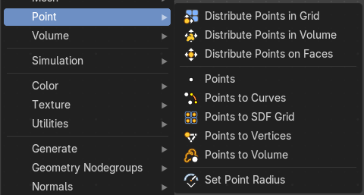

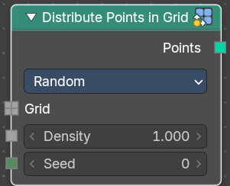
Distribute Points In Grid
Distributes points randomly in a grid.
Point, corner and polygon attributes of the input geometry are transferred to the generated points. That includes vertex weights and UV maps. Additionally, the node has Normal and Rotation outputs.
The node also generates a stable ID, which is then stored in the built-in id attribute. It is used as a stable identifier for each point. When the geoemetry is deformed or the density changes the values will be consistent for each remaining point. This attribute is used in the Random Value and Instance on Points nodes.

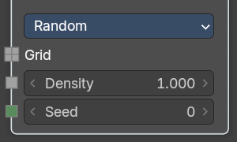
Inputs Random mode

Grid
The grid to import the points to.

Density
Density of the points.

Seed
The random seed for the point distribution.

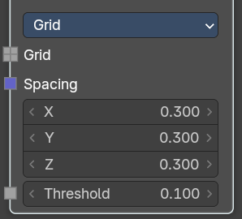
Inputs Grid mode

Grid
The grid to import the points to.

Spacing
The spacing between the grid points.

Threshold
Minimum density of a volume cell to contain a grid point.

Properties

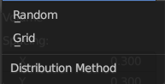
Distribution method

Random
Distributes the points randomly. This allows overlappings.

Grid
Distributes the points along a grid with given width.

Output

Points
Points output.

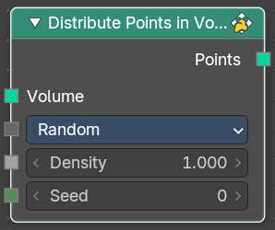
Distribute Points In Volume
Distributes points randomly in a volume.
Point, corner and polygon attributes of the input geometry are transferred to the generated points. That includes vertex weights and UV maps. Additionally, the node has Normal and Rotation outputs.
The node also generates a stable ID, which is then stored in the built-in id attribute. It is used as a stable identifier for each point. When the geoemetry is deformed or the density changes the values will be consistent for each remaining point. This attribute is used in the Random Value and Instance on Points nodes.

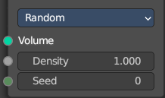
Inputs Random mode

Volume
The volume to import the points to.

Density
Density of the points.

Seed
The random seed for the point distribution.

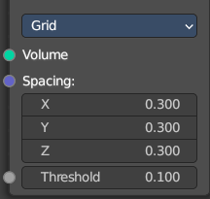
Inputs Grid mode

Volume
The volume to import the points to.

Spacing
The spacing between the grid points.

Threshold
Minimum density of a volume cell to contain a grid point.

Properties

Distribution method

Random
Distributes the points randomly. This allows overlappings.

Grid
Distributes the points along a grid with given width.

Output

Points
Points output.

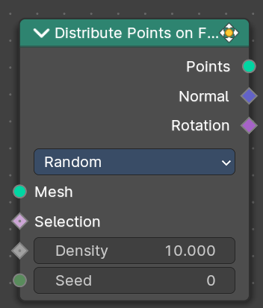
Distribute Points on Faces
Distributes points randomly on the faces of a mesh geometry.
Point, corner and polygon attributes of the input geometry are transferred to the generated points. That includes vertex weights and UV maps. Additionally, the node has Normal and Rotation outputs.
The node also generates a stable ID, which is then stored in the built-in id attribute. It is used as a stable identifier for each point. When the mesh is deformed or the density changes the values will be consistent for each remaining point. This attribute is used in the Random Value and Instance on Points nodes.

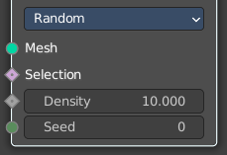
Inputs Random mode

Mesh
Standard geometry input.

Selection
The selection of which face corners should be considered for point distribution.

Density
Density of the points.

Seed
The random seed for the point distribution.

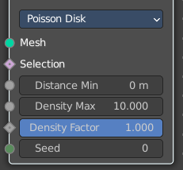
Inputs Poisson Disk mode

Mesh
Standard geometry input.

Selection
The selection of which face corners should be considered for point distribution.

Distance Min
The minimum distance that two points can have.

Distance Max
The naximum distance that two points can have.

Density Factor
Density of the points.

Seed
The random seed for the point distribution.

Properties

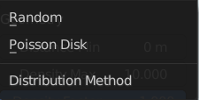
Distribution method

Random
Distributes the points randomly. This allows overlappings.

Poisson Disk
Distributes the points randomly, but prevents overlappings by defining a minimum and maximum distance.

Output

Points
Points output.

Normal
Normal output.

Rotation
Euler Rotation output. Please note that the Z axis of the result rotation will be arbitrary. The mesh normal used to create the rotation does not have enough information to set all three rotation axes.
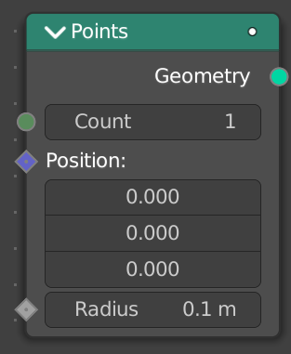

Points
Generates a single point or points with position, count and radius.

Inputs

Count
The count of the generated points as an integer.
Position
The position of the points as a vector. This is a field meaning you can set the position per index or ID of the point.
Radius
The radius of the points as a float. This is a field meaning you can set the scale per index or ID of the point.

Outputs

Mesh
Standard mesh output.

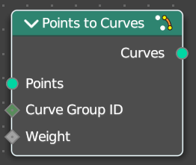
Points to Cuves
Generates a mesh vertex in the output geometry for each point cloud point in the input geometry.

Inputs

Points
Points input.

Curve Group ID
A curve is created from every distinct group ID. All points with the same ID are put into the same curve.

Selection
Selection input.

Outputs

Mesh
Standard mesh output.

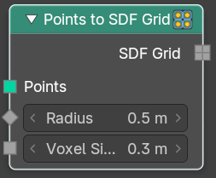
Points to SDF Grid
Generates a mesh vertex in the output geometry for each point cloud point in the input geometry.

Inputs

Points
Points input.

Radius
The radius of the grid.

Voxel size
The voxel size of the grid.

Outputs

SDF Grid
Standard mesh output.

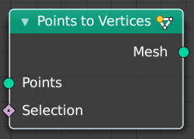
Points to Vertices
Generates a mesh vertex in the output geometry for each point cloud point in the input geometry.

Inputs

Points
Points input.

Selection
Selection input.

Outputs

Mesh
Standard mesh output.

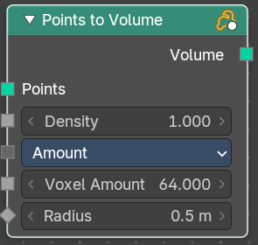
Points to Volume
Creates a fog volume sphere around every point in the input geometry. The new volume grid is then called density.

Inputs

Points
Points input.

Density
The density of the volume.

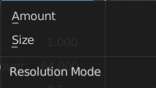
Resolution Mode
Base the voxel resolution at the amount or the size of the point cloud.

Voxel Amount
Voxel amount of the volume.

Radius
The radius of the generated volume around each point.

Outputs

Volume
Standard geometry output.

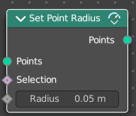
Set Point Radius
The Set Point Radius node controls the size each selected point cloud point should display with in the viewport.

Inputs

Points
Geometry input.

Selection
Selection input.

Radius
The radius of the points.

Outputs

Points
Standard geometry output.

